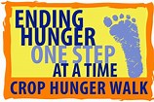
CROP HUNGER WALK 2020
Crop Walk is a global initiative sponsored by Church World Services. Its purpose is to stamp out hunger and to lift people out of poverty. This year marks the 20th year of Crop Walk in Southeast Sussex County. On Sunday, October 18th—3:30 PM @ OLG, St. Ann’s/OLG will do their part to overcome hunger and poverty by participating in Crop Walk. We will begin with prayer and music in church, provided by the Saint Ann’s Contemporary Music Ensemble. Our walk will then begin around the parking lot at OLG. All are invited to participate. If you are unable to walk, you may come for prayer and music in the church.
It is important to note that 25% of all monies collected from Crop Walk in our area will be distributed among the 5 food pantries in the Ministerium. We are all able to appreciate how our Food Banks are being challenged at this time, so all donations are greatly appreciated.
Donations may be made by check and made out to CWS. They either may be mailed to St. Ann’s Church with (att: Crop Walk) on the envelope, or they may be placed in an envelope labeled Crop Walk and placed in the donation baskets at the doors of both St. Ann’s and OLG.
Participants must wear a mask and sign a release form prior to the walk.
Let us support our sisters and brothers in need and one another in our Crop Walk.
For additional information please contact your Team Leaders:
Tish Galu patriciagalu@gmail.com 1-919-225-2986
Sister Loretta rett1122@yahoo.com 1-302-829-8183
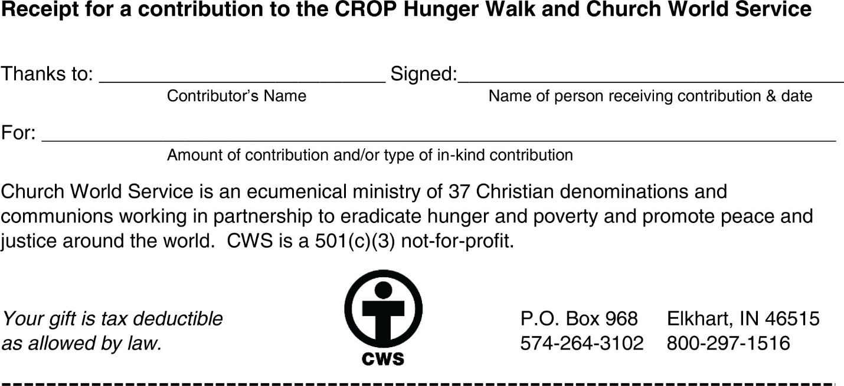
If making a donation, please fill in the receipt below and keep for your records.
Tish Galu & Sr. Loretta C. Primus--10/18/20

