Saint Ann Conference, Saint Vincent de Paul
  - Meeting Minutes
Date June 13, 2023
Next meeting: |  | Tuesday, June 27 at 3:30PM in Delaney Hall
 |  | Tuesday, August 22 at 3:30PM in Delaney Hall

- Call to Order; Opening Prayer
Mary Ann Conlon opened the meeting at 9:30 AM.

- Welcome
  - Two new members were welcomed to the conference.
  - Carol requested prayers for those in our Vincentian family who are ill.
  - Janet Skibicki gave an update on preparations for the “Breaking Bread Together Fiesta this coming Friday.
  - Volunteers will move chairs, etc. from St. Ann at 7:45 AM
  - Setup will begin at noon
  - Volunteers are asked to report at 3:30 PM
  - Will need additional volunteers for cleanup, trash disposal, etc
  - Material from St. Ann will be returned Saturday morning at 8:00AM
  - Members are asked to park to the right of OLG

- Approval of Minutes
Minutes of the 5/23 meeting were approved by a voice vote.

- Treasurer’s Report
Beginning Balance Checking Account 5/1/23 65,394.
Revenues 20,357.
Expenses 21,273.
Ending Balance Checking Account 5/31/23 64,478.
We have approximately $45K in our development account.

- Pastoral Council Update
  - There was no meeting this past month.

- Ministerium Update
  - Of particular interest to our members, there was a discussion regarding the Beebe Mobile Unit. Plans are underway to site the healthcare unit at OLG once a month, when the food pantry is open. More information will follow, including proposed dates.
  - Reminder that the CROP walk will be held at OLG on October 15. We need more members in attendance at this event; our food pantry is one of the beneficiaries.

- Updates
  - Food Pantry
    - Tom Hill advised members of the new 10x17 storage facility we’ve rented behind Al Casapulla’s on Atlantic Avenue (photo attached, ATTACHMENT 1). This leaves us with two facilities for storage of pantry goods, and a third for furniture, etc.
    - St. Edmond’s is regularly delivering produce from their local farmer’s market, to supplement our own garden.
    - Pantry numbers are down, overall. We’re considering changing the hours of the second Thursday to later in the afternoon, to accommodate those who are are unable to attend due to job.
  - Garden Team
    - The garden was hard-hit by the recent hailstorm, but most of the damage seems to be recoverable.
  - Neighbor Contact
    - We are setting up a new series of cross-team meetings for NCT, similar to what we held previously, to get information to the teams on new resources and programs that are available.
    - Housing update: There will be a rally in Dover in support of new housing legislation, including:
      - SD1 – setting up an escrow account to hold rent payments to landlords who are delinquent in repairs
      - HB191 – providing legal help for evictions
      - HB212 – establishing rent control for mobile/manufactured homes
      - SB120 – making affordable housing projects eligible for funding from realty transfer taxes
  - Visiting Vincentians
    - We’ve been able to match up a new volunteer with a new request from Brandywine for a resident there; plans are to take this neighbor to mass and breakfast.
  - Extended Care
    - The team is trying to contact Carlos Mitchell, to work with him on an ongoing basis. He is still calling the regular NCT number for assistance; if we receive a call from him, he should be gently referred to Extended Care.
  - Fund Raising
    - Barbara McInerney is hosting a Pampered Chef party at her home on 6/27. If planning to attend, pease RSVP; orders can also be placed online (see ATTACHMENT 2).
  - Building Plans
    - Received initial artist renderings of the planned construction; a drawing was circulated amont the attendees, but it is not for general districution yet.
    - Spoke to Fr. Klevence re the current plans; he suggested a Capital Campaign to contribute to the building expenses.
    - Virginia is writing grant requests ti be submitted to the state, county, Catholic Charities, and other funding sources that we have identified.
    - May consider a donor wall at the entrance to encourage additional sponsorship and donations.
    - FYI, the Diocese requires 3 bids on everything, prior to approval

- Spirituality – Persuasion
Discussion was based on John’s Gospel for Pentecost Sunday (Jn 20:19-23). For meditation and group sharing: “Have I ever experienced how God unexpectedly intervened and guided the course of events?”

- President’s Remarks
- Tish advised members that St. Ann will be piloting a program titled “Pathways to a Brighter Tomorrow,” which will assist neighbors in obtaining available funding and assistance, identifying opportunities for advancement, and setting goals.
  - Tish also stressed the importance of home visits. Not only are they a cornerstone of the SSVdP, but they also enable us to gain a broader picture of the needs and vulnerabilities of our neighbors who have come to us for help.
  - Reminder that the September annual meeting will be held on September 25 at St. John the Beloved.
  - Our conference will be holding a retreat on October 28; mark your calendars!
Volunteers needed for our school supplies drive. This year we will be storing and staging supplies off site; Zoar UMC in Selbyville has graciously offered their facilities.

- Upcoming Events
June 26 | Team 2, Food Pantry June 29  Regular Meeting 6/27 @ 3:30 PM  NCT Meeting at 2:30 PM in DH
Note No Regular Meetings until August 22
July 3 | Team 3, Food Pantry July 6  NCT Monday 7/3 @ 1:00 PM @ OLG  NCT on Thursday 7/7 @ Noon @ OLG
July 10 | Team 4, Food Pantry July 13 3:00 – 5:00 PM
July 17 | Team 1, Food Pantry July 20  Building Group Meeting 7/18 @ 9:30 AM @ OLG
July 24 | Team 2, Food Pantry July 27
July 31 | Team 3, Food Pantry Aug. 3  Building Group Meeting 8/1 @ 9:30 AM @ OLG
Aug. 7 | Team 4, Food Pantry Aug. 10 3:00 – 5:00 PM
Aug. 14 | Team 1, Food Pantry Aug. 17  Building Group Meeting 8/18 @ 9:30 AM location TBD
Aug. 21 | Team 2, Food Pantry Aug. 24  Regular Meeting Aug. 22 @ 3:30 PM DH  School Supplies Evaluation Meeting PRIOR to Regular Meeting @ 2:30 PM
Aug. 28 | Team 3, Food Pantry Aug. 31  Building Group Meeting 8/29 @ 9:30 AM location TBD
Sept 4 | Team 4, Food Pantry Sept 7
Sept. 11 | Team 1, Food Pantry 9/14 @ 3:00 PM, Regular Meeting 9/12 @ 9:30, Building Group Meeting 9/12 @ 9:30 AM Location TBD  Giving Tree Meeting after Regular Meeting
Sept. 18 | Team 2, Food Pantry 9/21  Sunday, September 24 Annual SVdP Conference Meeting
Sept. 25 | Team 3, Food Pantry 9/28  Regular Meeting 9/26 @ 3:30 PM DH  Building Group Meeting 9/26 @ 9:30 AM Location TBD  Team Leader Meeting at 2:00 PM in DH
Oct. 2 | Team 4, Food Pantry 10/5  Saturday, Oct. 7 Corn Hole for a Cause
Oct. 9 | Team 1, Food Pantry 10/12 @ 3:00 PM  Regular Meeting 10/10 @ 9:30 AM DH  Sunday, October 15 @ 2:30 PM Crop Walk
Oct. 16 | Team 2, Food Pantry 10/19  Ozanam Orientation on Tuesday, Oct. 17 10:00 AM to 4:00 PM
Oct. 23 | Team 3, Food Pantry 10/26  Regular Meeting 10/24 @ 3:30 PM in DH  Saturday, October 28 SVdP ½ Day of Recollection on Spirituality in DH
Oct. 30 | Team 4, Food Pantry 11/2
Nov. 6 | Team 1, Food Pantry 11/9 @ 3:00 PM
Nov. 13 | Team 2, Food Pantry 11/16  Regular Meeting 11/14 @ 9:30 AM
Nov. 20 | Team 3, No Scheduled Food Pantry due to Thanksgiving 11/23
Nov. 27 | Team 4, Food Pantry 11/30  Regular Meeting 11/28 @ 3:30 PM DH
Dec. 4 | Team 1, Food Pantry 12/7
Dec. 11 | Team 2, Food Pantry 12/14 @ 3:00 PM  Regular Meeting 12/12 @ 9:30 AM
Dec. 18 | Team 3, Food Pantry 12/21
Dec. 25 | Team 4, Food Pantry 12/28

- Closing Prayer; Adjournment

ATTACHMENT 1
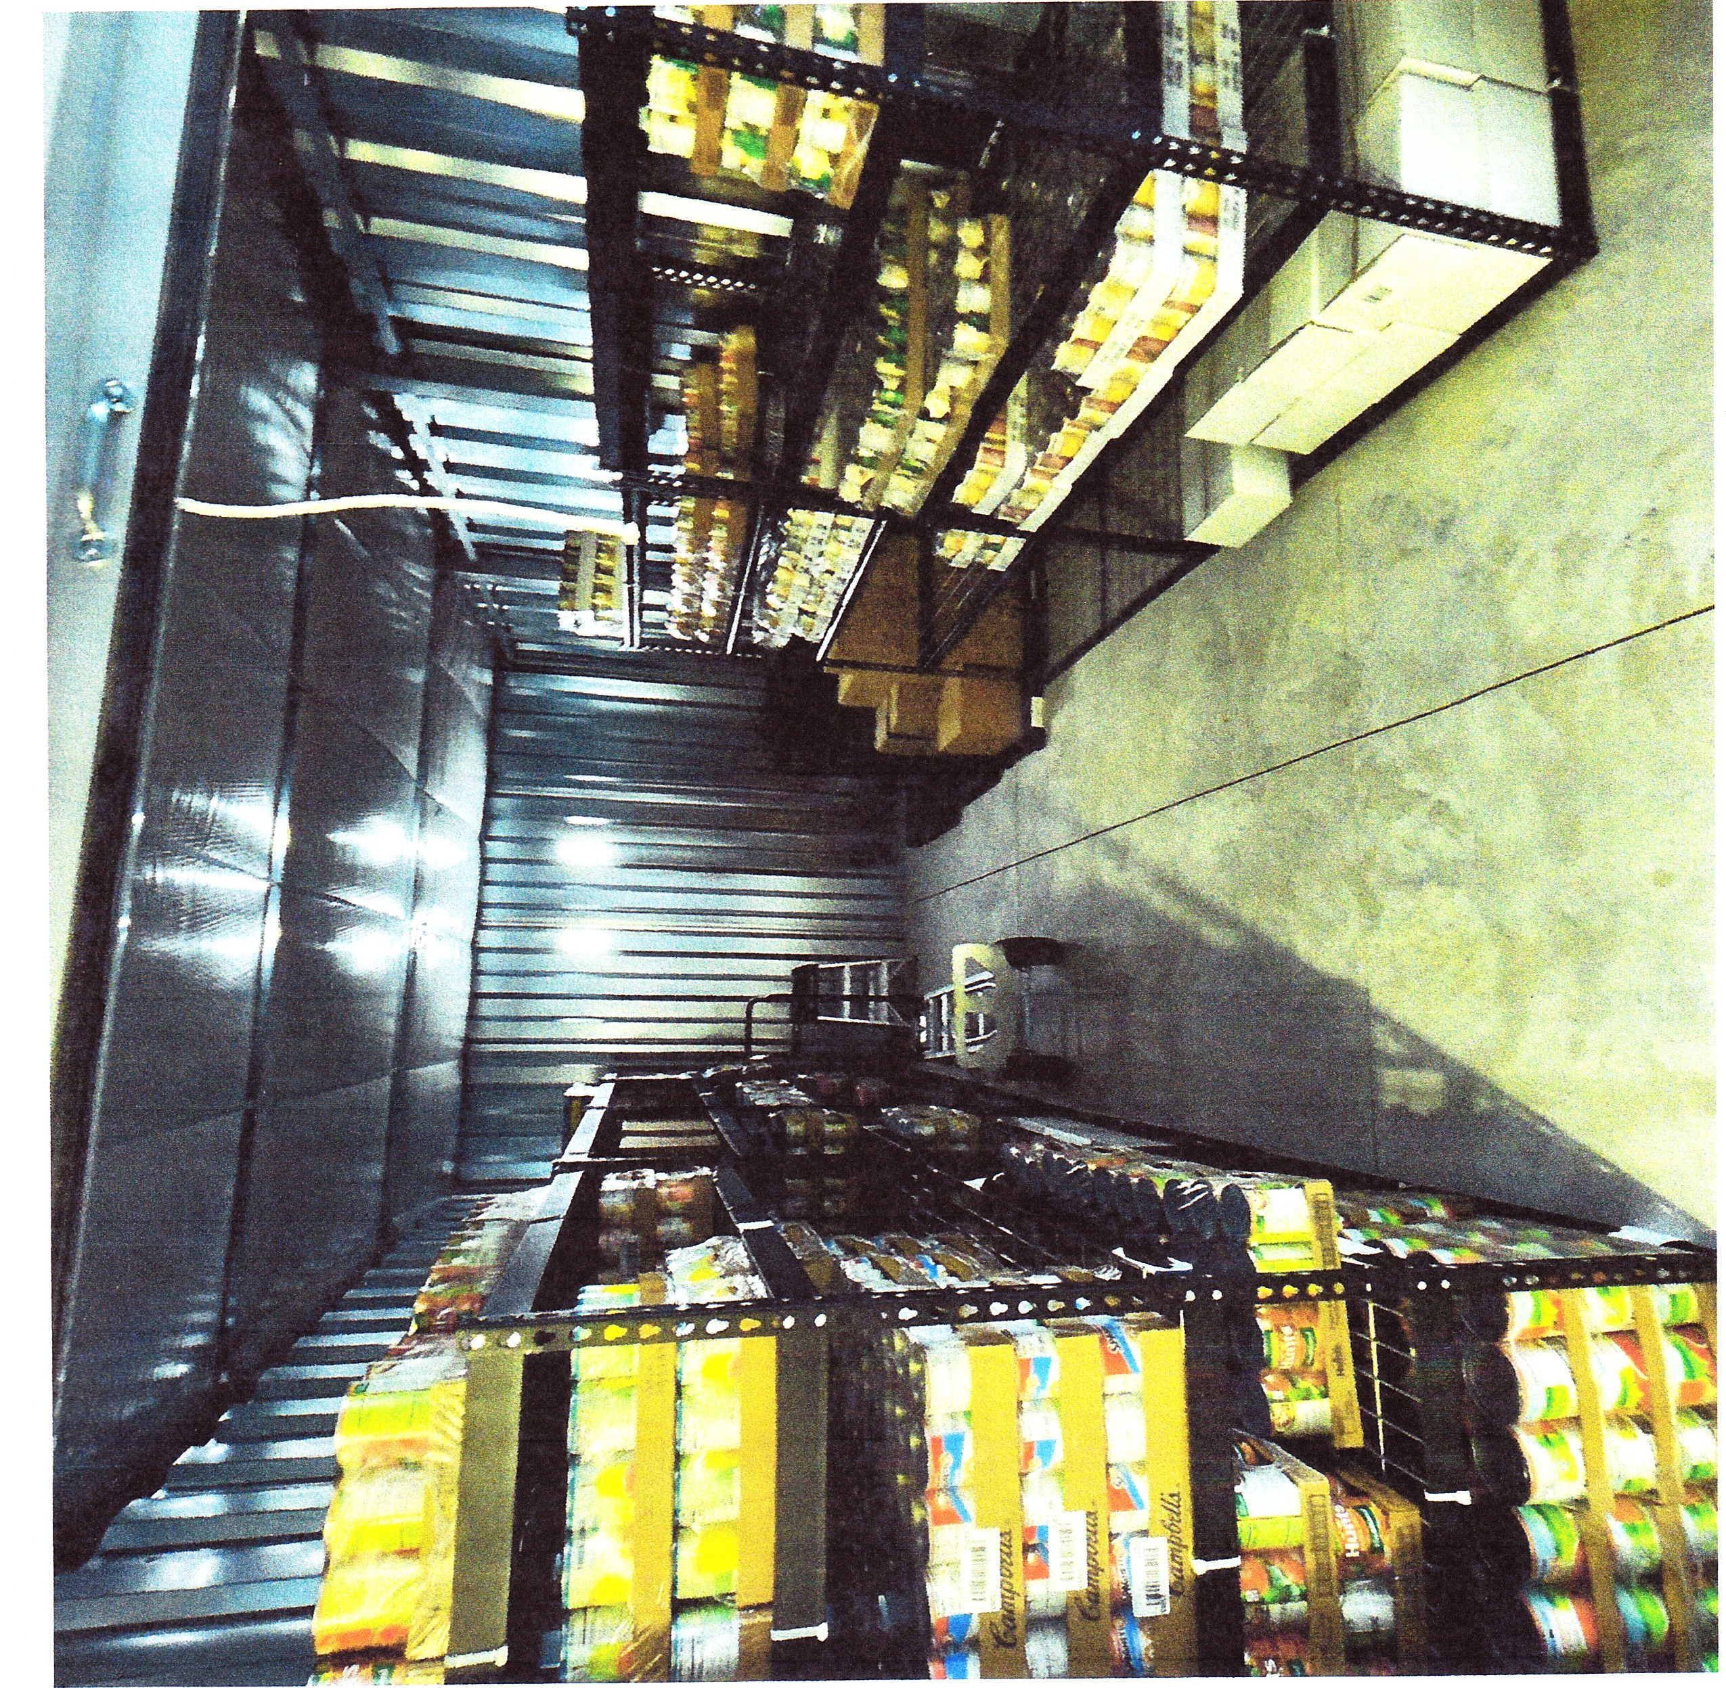

ATTACHMENT 2

